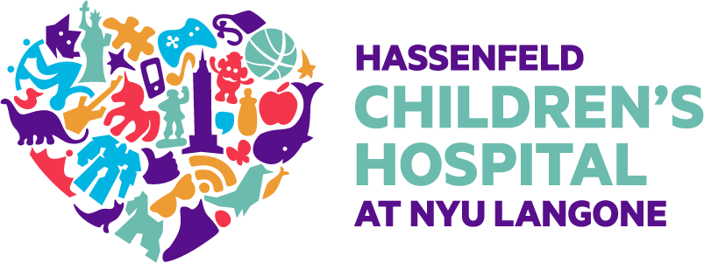

StimQ₂©
Translation Policy and Guidelines

The StimQ₂ is an instrument measuring cognitive stimulation in the homes of children. It is available for three age ranges—5 to 12 months (Infant), 12 to 36 months (Toddler), and 36 to 72 months (Preschool), and consists of 4 Scales—READ, Parental Involvement in Developmental Advance (PIDA), Parental Verbal Responsivity (PVR), and Availability of Learning Materials (ALM). It has been translated and validated in English and Spanish.

While we welcome the opportunity to expand the use of StimQ₂ in other languages and cultures, we do not have the in-house capacity to provide translations of the measure in other languages at this time. However, you may submit a request to translate the measure or one/more of its Scales, provided the following policies and guidelines are followed.

FORMAL PROCESS
- Fill out the following request form: https://redcap.link/hg8gzxaj
- Once approval has been granted, you may translate the StimQ₂ per the guidelines listed below
- We request that you provide us with both the translation AND the back-translation for our review
- We will offer feedback on the back-translation provided, which may require clarifications of cultural idiosyncrasies or colloquialisms, modifications, or corrections.
- Once our questions are addressed and/or feedback integrated, we will approve a final translation.
- Please note that we would want to eventually make the final-approved translation available publicly on our website. Therefore, we will also require permission from the translator and/or back-translator to include his/her/their name(s) in a note of acknowledgement for their contribution to the translating effort.
- Finally, we also ask that should your work be accepted for publication, based on analyses completed using the StimQ₂, you share a copy of the accepted paper with us (in the language of publication).

TRANSLATION GUIDELINES
- We recommend using the English instrument as the original template
- Two (2) people with comparable language fluency in English and the language of translation should work on the translation
  - Translator – translates the original English instrument from English ________
  - Back-translator – translates the translation (by Translator) back into English WITHOUT consulting the Translator OR referencing the original English instrument.
- It is fine to consult online translators for specific words or phrases, but note that these do not usually provide reliable nuanced translations, and should therefore NOT be used to translation the full instrument, or even full sentences.

